How to share a stack

This document gives the complete process to share a stack with others (who may not have a MadeiraCloud account). Typical use cases of this include: setup Demo/POC environment for potential clients, prepare lab environments for training, etc.

Note: if you are new to MadeiraCloud and do not know how to create a stack/app, please refer our knowledge base.

- Prerequisite
- MadeiraCloud account
- Ready-to-go stack
- Guest’s email address
- (optional) invitation property (like how long your guest can use it)

- Invite
- Log in IDE and open the stack you want to share
- Click the “Share” button
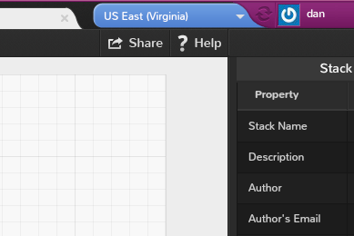

- “Invite limitations” shows the property you can set for the invitation:
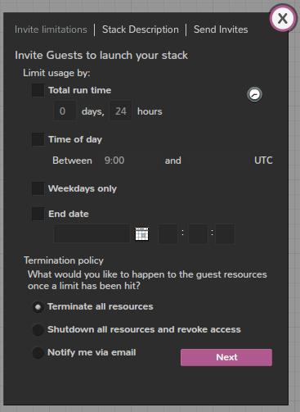
- Limit usage by:
  - Total run time: the total run hours of any app launched by the guest from the shared stack
  - Time of day: when the guest apps can run (for example: automatically start the app at 9:00am and shutdown at 17:00pm)
  - Weekday only: if checked, the guest apps can only run in weekdays (auto-shutdown during the weekend to save cost)
  - End date: the hard limit when this invitation (and associated guest apps) is expired
- Termination policy
  - Terminate all resources: if checked, the guest app will be terminated and all resource in the app will be destroyed
  - Shutdown all resource and revoke access: the guest app (and all related resources) will be stopped. The guest cannot access the app any longer
  - Notify me via email: in this case, the guest app will be left running, a notification will be sent to your email address (Note, in the above two cases, email notification is also sent)

- Write additional information in “Stack Description” (shown to the guest when they login):
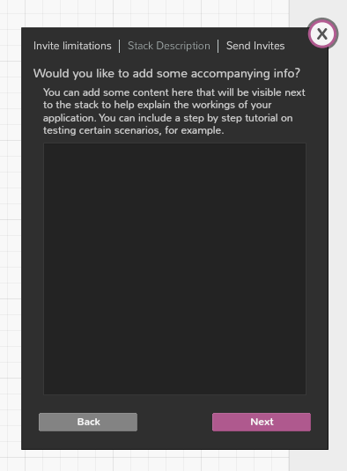

- Enter the guest email address:
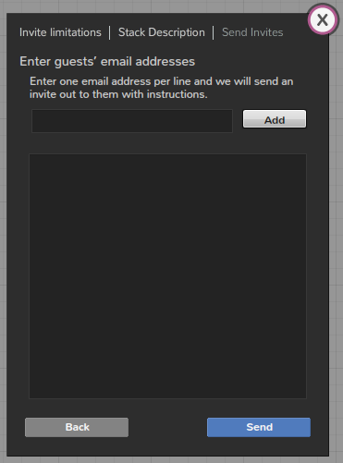

- Click the “Send” button, a new request will be submitted. Once done, your invitation have been sent to the guests.
- View and cancel invitations
You may want to view all invitations you have sent out (who, which stack, how long the invitation is valid, etc), and you may want to cancel some due to various reasons. We allow you to do that.

